|  |  |
| --- | --- |
| Operatör: | |
|  | |
| Tillståndsnummer: | Kontaktperson: |
|  |  |
|  | Bilaga nr: |
| Relevant elements defined in the mandatory part of the operational suitability data established in accordance with Regulation (EU) No 748/2012 are taken into account |  |
| Transportstyrelsen | |
| Ärendenummer: | Handläggare: |
|  |  |
| Berörda sektioner/samråd: | |
|  | |
| Information | |
|  | |
| Denna checklista är avsedd som stöd vid ansökan om ”Helikoptrars inflygningar och starter med PINS (point-in-space) och reducerade VFR-minima (PINS-VFR)”  Ange var i det operativa manualverket (eller i annat styrande dokument) momentet återfinns och detta så detaljerat som möjligt för att underlätta och påskynda granskning och handläggning.  Om en punkt inte är relevant, markera rutan med N/A samt en förklaring varför den inte är relevant Relevanta bilagor ska bifogas och referens till dessa ska anges i checklistan.  Formatet och strukturen i den operativa manualen bör följa den rekommenderade ordningen i ORO.MLR.100 med tillhörande AMC. | |

**SPA.PINS-VFR.100 Helicopter point-in-space (PinS) approaches and departures with reduced VFR minima**

|  |  |  |
| --- | --- | --- |
|  | Kommentarer / Referens i OM / Bilaga nr: | TS notering: |
| **(a)** The operator shall only use reduced VFR operating minima where both of the following conditions are met: |  |  |
| (a)(1) the operations are not conducted under a HEMS approval |  |  |
| (a)(2) the operator has been granted an approval by the competent authority |  |  |
| **(b)** Reduced VFR operating minima shall apply only to a helicopter flight that includes a segment flown under IFR, and only in one of the following cases: |  |  |
| (b)(1) the segment of the flight flown under VFR takes place immediately after a helicopter PinS approach with the intention of landing at a nearby heliport or operating site; |  |  |
|  | Kommentarer / Referens i OM / Bilaga nr: | TS notering: |
| (b)(2) the segment of the flight flown under VFR takes place immediately after a helicopter PinS approach with the intention of conducting hoist operations at a nearby HEC or HHO site; |  |  |
| (b)(3) the segment of the flight flown under VFR is a departure with the intention of transitioning to IFR at a nearby initial departure fix. |  |  |
| **(c)** The operator shall define operating procedures that are applicable when flying with reduced VFR operating minima. |  |  |
| **(d)** The operator shall ensure that flight crew members are experienced and trained to operate with reduced VFR operating minima. |  |  |
|  |  |  |
| **AMC1 SPA.PINS-VFR.100 Helicopter point-in-space (PinS) approaches and departures with reduced VFR minima** | | |
|  | Kommentarer / Referens i OM / Bilaga nr: | TS notering: |
| GENERAL **(a)** The operating minima prescribed in the Annex (Rules of the air) to Regulations (EU) No 923/2012 should apply under VFR, unless one of the following applies: |  |  |
| (a)(1) The VFR segment of the flight follows a PinS approach and the distance from the missed approach point (MAPt) to the destination is less than 5 km. |  |  |
| (a)(2) The VFR segment of the flight is a departure with the intention of transitioning to IFR at the IDF and the distance from the take-off to the initial departure fix (IDF) is less than 5 km. |  |  |
| (a)(3) The VFR segment of the flight follows the planned cancellation of the IFR flight plan at or above the MAPt or decision point of an instrument approach, the destination is different from the aerodrome attached to the instrument approach, the distance from the planned point of cancellation of IFR to the destination is less than 5 km, and the operator charts the obstacle environment on the VFR segment of the flight. |  |  |
| **(b)** By day, if either (a)(1) or (a)(2) applies, the operating minima in Tables 1 and 2 should apply and visual references to the ground should be maintained. |  |  |

|  |  |  |
| --- | --- | --- |
|  | Kommentarer / Referens i OM / Bilaga nr: | TS notering: |
| **(c)** By night, if either (a)(1) or (a)(2) applies, the operating minima in Tables 3 and 4 should apply and visual references to the ground should be maintained. |  |  |
| **(d)** If (a)(3) applies, Tables 1 applies by day, Table 3 applies by night, and visual references to the ground should be maintained. The MDH in the table should be understood as the DH/MDH of the IAP, whichever I higher. |  |  |

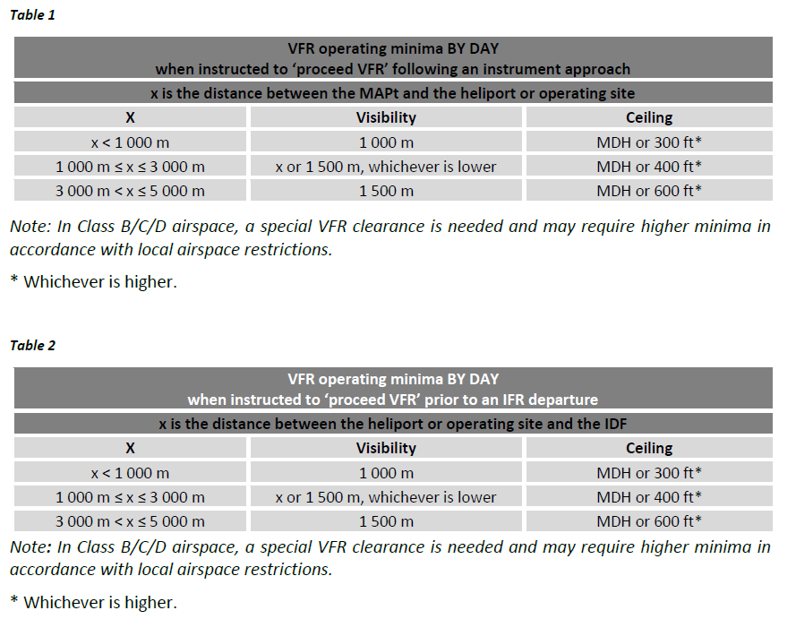

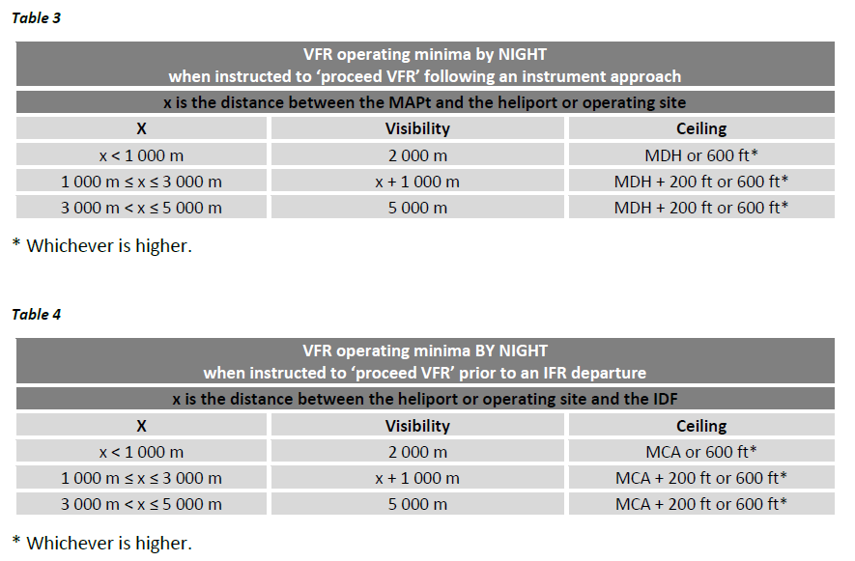

|  |  |  |
| --- | --- | --- |
|  | Kommentarer / Referens i OM / Bilaga nr: | TS notering: |
| **(e)** The operator should define SOPs that describe the VFR segment of the departure and approach including the transition from IFR to VFR and the transition from VFR to IFR. |  |  |
| **(f)** The operator should provide a thorough description of the following elements; the description may be provided by means of a chart and should be included in the operations manual or other document: |  |  |
| (f)(1) the environment in the vicinity of the VFR segment of the flight |  |  |
| (f)(2) the visual cues that are useful for the purpose of VFR navigation and that should be available on departure or for the continuation of the flight at the MAPt; |  |  |
| (f)(3) the relevant obstacles |  |  |
| **(g)** The operator should ensure that the elements in (f) are updated on a regular basis |  |  |
| **(h**) The operator should encourage occurrence reporting and have a safety analysis capability |  |  |

|  |  |  |
| --- | --- | --- |
|  | Kommentarer / Referens i OM / Bilaga nr: | TS notering: |
| **(i)** The pilot-in-command/commander should have at least 1 000 hours of flying experience on helicopters, and 100 hours of instrument time on helicopters. |  |  |
| **(j)** The pilot-in-command/commander should undergo initial and yearly recurrent FSTD training or checking, covering the following items: |  |  |
| (j)(1) 3D approach operation to minima; |  |  |
| (j)(2) go-around on instruments; |  |  |
| (j)(3) 2D approach operation to minima; |  |  |
| (j)(4) at least one of the 3D or 2D approach operations should be a PinS approach followed by a transition to VFR and a VFR landing; |  |  |
| (j)(5) in case of multi-engined helicopters, a simulated failure of one engine should be included in either the 3D or 2D approach operation to minima; |  |  |
| (j)(6) where appropriate to the helicopter type, approach with flight control system/flight director system malfunctions; flight instrument and navigation equipment failures; |  |  |
| (j)(7) recovery from unusual attitudes by instrument; |  |  |
| (j)(8) loss of VMC during the VFR segment of flight; |  |  |
| (j)(9) VFR departure followed by a manoeuvre back to the take-off location; |  |  |
| (j)(10) VFR departure to the IDF followed by an IFR departure |  |  |
| **(k)** The training and checking elements of an approved training programme may be credited towards compliance with point (j) and need not be duplicated. |  |  |
| **(l)** The training under (j) should take place on a suitable FSTD, corresponding to the helicopter type on which the operations take place. |  |  |