COMPLIANCE CHECKLIST*

SPA.SET-IMC
SINGLE-ENGINED TURBINE AEROPLANE OPERATIONS AT NIGHT OR IN INSTRUMENT METEOROLOGICAL CONDITIONS (SET-IMC)

Version 2017-03-02

COMMISSION REGULATION (EU) No 965/2012 of 5 October 2012

Updated with Commission Regulations:
(EU) 2017/363, 01 Mar 2017 (SET-IMC)

Updated with ED-Decisions (AMC/GM):
2017/004/R (amending Acceptable Means of Compliance and Guidance Material to Part-ARO, Part-ORO, Part-CAT and Part-SPA of Regulation (EU) No 965/2012)

Name of organisation
AOC reference
Audit reference | TSL
TSL Audit staff
Signature
TSL Audit staff
Signature
Date(s) of audit
Date of completion

How to use Compliance Checklist (CCL)

This Compliance Checklist is meant to be an aid to show compliance with the rules in an application for part SPA, subpart L, SINGLE-ENGINED TURBINE AEROPLANE OPERATIONS AT NIGHT OR IN INSTRUMENT METEOROLOGICAL CONDITIONS (SET-IMC). The CCL encompass the Implementing Rules as well as the associated AMCs and GMs.

In addition, annex III (Part-ORO) and annex IV (part-CAT) are amended. The operator is responsible for compliance:
Ref. ORO.GEN.110, CAT.OP.MPA.136, CAT.OP.MPA.180, CAT.POL.A.300 and CAT.POL.A.320 with associated AMCs and GMs.

Every rule reference in this document is followed by a box where the operator, in the first column, shall state where in the Operations Manual the subject is described. It will not be acceptable with just “OM-A” or “OM-A chapter 5”; the reference must be to the detailed level to facilitate the review.

The two following columns are solely for the use of the Authority.

State how and where the rule is implemented  (Ex. Ref. to OM-A 5.4.3.5)  If the rule is Not Applicable state N/A | SCAA notes | **  Assessment

*Note: Disclaimer: This document is meant as an aid for operators to comply with the applicable rules. If any differences or discrepancies would exist between this document and the applicable EU regulations and EASA AMC/GM/CS the latter prevail and must always be consulted.

** Note: The right hand part of each box above to be completed by SCAA with one of four indicators:
1. C means Compliance;
2. N/A means that the rule is Not Applicable to the reviewed activity;
3. N/R means the rule is applicable but Not Reviewed;
4. R means Remark.

.

The application shall contain
- EASA Form 2, signed by Accountable Manager
- This compliance checklist filled as applicable
- Supporting documents of aircraft capability
- Revisions of applicable operations manuals and Aircraft Maintenance Programme
- Supporting documents of simulator capability

ANNEX V

SPECIFIC APPROVALS
[PART-SPA]

SUBPART L

SINGLE-ENGINED TURBINE AEROPLANE OPERATIONS AT NIGHT OR IN INSTRUMENT METEOROLOGICAL CONDITIONS (SET-IMC)

SPA.SET-IMC.100SET-IMC operations
In commercial air transport (CAT) operations, single-engined turbine aeroplanes shall only be operated at night or in IMC if the operator has been granted a SET-IMC approval by the competent authority;

SPA.SET-IMC.105SET-IMC operations approval
To obtain a SET-IMC approval by the competent authority, the operator shall provide evidence that all the following conditions have been complied with:

(a) an acceptable level of turbine engine reliability is achieved in service by the world fleet for the particular airframe-engine combination;

(b) specific maintenance instructions and procedures to ensure the intended levels of continued airworthiness and reliability of the aeroplane and its propulsion system have been established and included in the operator's aircraft maintenance programme in accordance with Annex I to Regulation (EU) No 1321/2014 (Part-M), including all the following:

- an engine trend monitoring programme, except for aeroplanes first issued with an individual certificate of airworthiness after 31 December 2004 that shall have an automatic trend monitoring system;

- a propulsion and associated systems' reliability programme;

(c) flight crew composition and a training/checking programme for the flight crew members involved in these operations have been established;

(d) operating procedures have been established specifying all the following:

- the equipment to be carried, including its operating limitations and appropriate entries in the MEL;

- the flight planning;

- the normal procedures;

- the contingency procedures, including procedures following a propulsion system failure, as well as forced landing procedures in all weather conditions;

- the monitoring and incident reporting.

(e) a safety risk assessment has been performed, including the determination of an acceptable risk period if an operator intends to make use of it.

AMC1 SPA.SET-IMC.105 SET-IMC operations approval
ANNUAL REPORT

After obtaining the initial approval, the operator should make available to its competent authority on an annual basis a report related to its SET-IMC operations containing at least the following information:

(a) the number of flights operated;

(b) the number of hours flown; and

(c) the number of occurrences sorted by type.

AMC1 SPA.SET-IMC.105(a) SET-IMC operations approval
TURBINE ENGINE RELIABILITY

(a) The operator should obtain the power plant reliability data from the type certificate (TC) holder and/or supplemental type certificate (STC) holder.

(b) The data for the engine-airframe combination should have demonstrated, or be likely to demonstrate, a power loss rate of less than 10 per million flight hours. Power loss in this context is defined as any loss of power, including in-flight shutdown, the cause of which may be traced to faulty engine or engine component design or installation, including design or installation of the fuel ancillary or engine control systems.

(c) The in-service experience with the intended engine-airframe combination should be at least 100 000 h, demonstrating the required level of reliability. If this experience has not been accumulated, then, based on analysis or test, in-service experience with a similar or related type of airframe and turbine engine might be considered by the TC/STC holder to develop an equivalent safety argument in order to demonstrate that the reliability criteria are achievable.

AMC1 SPA.SET-IMC.105(b) SET-IMC operations approval
MAINTENANCE PROGRAMME

The following maintenance aspects should be addressed by the operator:

(a) Engine monitoring programme
The operator’s maintenance programme should include an oil-consumption-monitoring programme that should be based on engine manufacturer’s recommendations, if available, and track oil consumption trends. The monitoring should be continuous and take account of the oil added. An engine oil analysis programme may also be required if recommended by the engine manufacturer. The possibility to perform frequent (recorded) power checks on a calendar basis should be considered.
The engine monitoring programme should also provide for engine condition monitoring describing the parameters to be monitored, the method of data collection and a corrective action process, and should be based on the engine manufacturer’s instructions. This monitoring will be used to detect propulsionsystem deterioration at an early stage allowing corrective action to be taken before safe operation is affected.

(b) Propulsion and associated systems’ reliability programme
A propulsion and associated systems’ reliability programme should be established or the existing reliability programme supplemented for the particular engine-airframe combination. This programme should be designed to early identify and prevent problems, which otherwise would affect the ability of the aeroplane to safely perform its intended flight.
Where the fleet of SET-IMC aeroplanes is part of a larger fleet of the same engine-airframe combination, data from the operator’s total fleet should be acceptable.
For engines, the programme should incorporate reporting procedures for all significant events. This information should be readily available (with the supporting data) for use by the operator, type certificate (TC) holders, and the competent authority to help establish that the reliability level set out in AMC1 SPA.SET-IMC.105(a) is achieved. Any adverse trend would require an immediate evaluation to be conducted by the operator in consultation with its competent authority. The evaluation may result in taking corrective measures or imposing operational restrictions.
The engine reliability programme should include, as a minimum, the engine hours flown in the period, the power loss rate for all causes, and the engine removal rate, both rates on an annual basis, as well as reports with the operational context focusing on critical events. These reports should be communicated to the TC holder and the competent authority.
The actual period selected should reflect the global utilisation and the relevance of the experience included (e.g. early data may not be relevant due to subsequent mandatory modifications that affected the power loss rate). After the introduction of a new engine variant and whilst global utilisation is relatively low, the total available experience may have to be used to try to achieve a statistically meaningful average.

AMC1 SPA.SET-IMC.105(c) SET-IMC operations approval
TRAINING PROGRAMME

The operator’s flight crew training and checking, established in accordance with ORO.FC, should incorporate the following elements:

(a) Conversion training

Conversion training should be conducted in accordance with a syllabus devised for SET-IMC operations and include at least the following:

- normal procedures:

- anti-icing and de-icing systems operation;

- navigation system procedures;

- radar positioning and vectoring, when available;

- use of radio altimeter; and

- use of fuel control, displays interpretation;

- abnormal procedures:

- anti-icing and de-icing systems failures;

- navigation system failures;

- pressurisation system failures;

- electrical system failures; and

- engine-out descent in simulated IMC; and

- emergency procedures:

- engine failure shortly after take-off;

- fuel system failures (e.g. fuel starvation);

- engine failure other than the above: recognition of failure, symptoms, type of failure, measures to be taken, and consequences;

- depressurisation; and

- engine restart procedures:
- choice of an aerodrome or landing site; and

- use of an area navigation system;

- air traffic controller (ATCO) communications;

- use of radar positioning and vectoring (when available);

- use of radio altimeter; and

- practice of the forced landing procedure until touchdown in simulated IMC, with zero thrust set, and operating with simulated emergency electrical power.

(b) Conversion checking

The following items should be checked following completion of the SET-IMC operations conversion training as part of the operator’s proficiency check (OPC):

- conduct of the forced landing procedure until touchdown in simulated IMC, with zero thrust set, and operating with simulated emergency electrical power;

- engine restart procedures;
(3) depressurisation following engine failure; and

(4) engine-out descent in simulated IMC.

(c) Use of simulator (conversion training and checking)

Where a suitable full flight simulator (FFS) or a suitable flight simulation training device (FSTD) is available, it should be used to carry out training on the items under (a) and checking of the items under (b) above for SET-IMC operations conversion training and checking.

(d) Recurrent training

Recurrent training for SET-IMC operations should be included in the recurrent training required by Subpart FC (FLIGHT CREW) of Annex III (Part-ORO) to Regulation (EU) No 965/2012 for pilots carrying out SET-IMC operations. This training should include all items under (a) above.

(e) Recurrent checking
The following items should be included into the list of required items to be checked following completion of SET-IMC operations recurrent training as part of the OPC:

- conduct of the forced landing procedure until touchdown in simulated IMC, with zero thrust set, and operating with simulated emergency electrical power;

- engine restart procedures;

- depressurisation following engine failure; and

- emergency descent in simulated IMC.

(f) Use of simulator (recurrent training and checking)

Following conversion training and checking, the next recurrent training session and the next OPCs including SET-IMC operations items should be conducted in a suitable FFS or FSTD, where available.

AMC2 SPA.SET-IMC.105(c) SET-IMC operations approval
CREW COMPOSITION

(a) Unless the pilot-in-command has a minimum experience of 100 flight hours under instrument flight rules (IFR) with the relevant type or class of aeroplane including line flying under supervision (LIFUS), the minimum crew should be composed of two pilots.

(b) A lesser number of flight hours under IFR on the relevant type or class of aeroplane may be acceptable to the competent authority when the flight crew member has significant previous IFR experience.

AMC1 SPA.SET-IMC.105(d)(2) SET-IMC operations approval
FLIGHT PLANNING

(a) The operator should establish flight planning procedures to ensure that the routes and cruising altitudes are selected so as to have a landing site within gliding range.

(b) Notwithstanding (a) above, whenever a landing site is not within gliding range, one or more risk periods may be used for the following operations:
- over water;

- over hostile environment; or

- over congested areas.
Except for the take-off and landing phase, the operator should ensure that when a risk period is planned, there is a possibility to glide to a non-congested area.
The total duration of the risk period per flight should not exceed 15 min unless the operator has established, based on a risk assessment carried out for the route concerned, that the cumulative risk of fatal accident due to an engine failure for this flight remains at an acceptable level (see GM2 SPA.SET-IMC.105(d)(2)).

(c) The operator should establish criteria for the assessment of each new route. These criteria should address the following:

- the selection of aerodromes along the route;
- the identification and assessment, at least on an annual basis, of the continued suitability of landing sites (obstacles, dimensions of the landing area, type of the surface, slope, etc.) along the route when no aerodrome is available; the assessment may be performed using publicly available information or by conducting on-site surveys;

- assessment of en route specific weather conditions that could affect the capability of the aeroplane to reach the selected forced landing area following loss of power (icing conditions including gliding descent through clouds in freezing conditions, headwinds, etc.);

- consideration of landing sites’ prevailing weather conditions to the extent that such information is available from local or other sources; expected weather conditions at landing sites for which no weather information is available should be assessed and evaluated taking into account a combination of the following information:
(i) local observations;

(ii) regional weather information (e.g. significant weather charts); and

(iii) terminal area forecast (TAF)/meteorological aerodrome report (METAR) of the nearest aerodromes; and

- protection of the aeroplane occupants after landing in case of adverse weather.

(d) At the flight planning phase, any selected landing site should have been assessed by the operator as acceptable for carrying out a safe forced landing with a reasonable expectation of no injuries to persons in the aeroplane or on the ground. All information reasonably practical to acquire should be used by the operator to establish the characteristics of landing sites.

(e) Landing sites suitable for a diversion or forced landing should be programmed into the navigation system so that track and distance to the landing sites are immediately and continuously available. None of these preprogrammed positions should be altered in-flight.

AMC2 SPA.SET-IMC.105(d)(2) SET-IMC operations approval
ROUTE AND INSTRUMENT PROCEDURE SELECTION

The following should be considered by the operator, as appropriate, depending on the use of a risk period:

(a) Departure
The operator should ensure, to the extent possible, that the instrument departure procedures to be followed are those guaranteeing that the flight path allows, in the event of power loss, the aeroplane to land on a landing site.

(b) Arrival
The operator should ensure, to the extent possible, that the arrival procedures to be followed are those guaranteeing that the flight path allows, in the event of power loss, the aeroplane to land on a landing site.

(c) En route
The operator should ensure that any planned or diversionary route should be selected and be flown at an altitude such that, in the event of power loss, the pilot is able to make a safe landing on a landing site.

AMC3 SPA.SET-IMC.105(d)(2) SET-IMC operations approval
LANDING SITE

A landing site is an aerodrome or an area where a safe forced landing can be performed by day or by night, taking into account the expected weather conditions at the time of the foreseen landing.

(a) The landing site should allow the aeroplane to completely stop within the available area, taking into account the slope and the type of the surface.

(b) The slope of the landing site should be assessed by the operator in order to determine its acceptability and possible landing directions.

(c) Both ends of the landing area, or only the zone in front of the landing area for one-way landing areas, should be clear of any obstacle which may be a hazard during the landing phase.

GM1 SPA.SET-IMC.105(d)(2) SET-IMC operations approval
LANDING SITE

(a) When selecting landing sites along a route to be operated, it is recommended to prioritise the different types of landing sites as follows:

- aerodromes with available runway lighting;

- aerodromes without available runway lighting;

- non-populated fields with short grass/vegetation or sandy areas.

(b) When assessing the suitability of a landing site which is not an aerodrome, it is recommended to consider the following landing site criteria:
- size and shape of the landing area:

(i) landing sites with a circular shape providing multiple approach paths depending on the wind; and

(ii) for other cases, landing sites with a minimum width of 45 m; and

- type of surface:
the surface of the landing area should allow a safe forced landing to be conducted.

GM2 SPA.SET-IMC.105(d)(2) SET-IMC operations approval
SAFETY RISK ASSESSMENT FOR A SPECIFIC ROUTE

(a) Introduction
The risk assessment methodology should aim at estimating for a specific route the likelihood of having fatalities due to emergency landing caused by engine failure. Based on the outcome of this risk assessment, the operator may extend the duration of the risk period beyond the maximum allowed duration if no landing site is available within gliding range.

(b) The safety target
The overall concept of SET-IMC operations is based on an engine reliability rate for all causes of 10 per million flight hours, which permits in compliance with SET-IMC requirements an overall fatal accident rate for all causes of 4 per million flight hours. Based on accident databases, it is considered that the engine failure event does not contribute by more than 33 % to the overall fatal accident rate. Therefore, the purpose of the risk assessment is to ensure that the probability of a fatal accident for a specific flight following engine failure remains below the target fatal accident rate of 1.3 × 10⁻⁶

(c) Methodology
The methodology aims at estimating the likelihood of failing to achieve a safe forced landing in case of engine failure, a safe forced landing being defined as a landing on an area for which it is reasonably expected that no serious injury or fatalities will occur due to the landing even though the aeroplane may suffer extensive damage.
This methodology consists of creating a risk profile for a specific route, including departure, en route and arrival airfield and runway, by splitting the proposed flight into appropriate segments (based on the flight phase or the landing site selected), and by estimating the risk for each segment should the engine fail in one of these segments. This risk profile is considered to be an estimation of the probability of an unsuccessful forced landing if the engine fails during one of the identified segments.
When assessing the risk for each segment, the height of the aeroplane at which the engine failure occurs, the position relative to the departure or destination airfield or to an emergency landing site en route, and the likely ambient conditions (ceiling, visibility, wind and light) should be taken into account, as well as the standard procedures of the operator (e.g. U-turn procedures after take-off, use of synthetic vision, descent path angle for standard descent from cruising altitude, etc.).
The duration of each segment determines the exposure time to the estimated risk. The risk is estimated based on the following calculation:
Segment risk factor = segment exposure time (in s)/3 600 × probability of unsuccessful forced landing in this segment x assumed engine failure rate per flight hour (FH).
By summing up the risks for all individual segments, the cumulative risk for the flight due to engine failure is calculated and converted to risk on a ‘per flight hour’ basis.
This total risk must remain below the target fatal accident rate of 1.3 × 10⁻⁶ as under (b) above.

(d) Example of a risk assessment
An example of such a risk assessment is provided below. In any case, this risk assessment is an example designed for a specific flight with specific departure and arrival aerodrome characteristics. It is an example of how to implement this methodology, and all the estimated probabilities used in the table below may not directly apply to any other flight.
The meaning of the different parameters used is further detailed below:
AD/Other: ‘AD’ is ticked whenever only aerodromes are selected as landing sites in the segment concerned. ‘Other’ is ticked if the selected landing sites in the segment concerned are not aerodromes. When a risk period is used by the operator, none of the two boxes (neither ‘AD’ nor ‘Other’) are ticked.
Segment exposure time: this parameter represents the duration of each segment in seconds (s).
Estimated probability of an unsuccessful forced landing if engine fails in the segment: probability of performing in the segment a safe forced landing following engine power loss.
Segment risk factor: risk of an unsuccessful forced landing (because of power loss) per segment (see formula above).

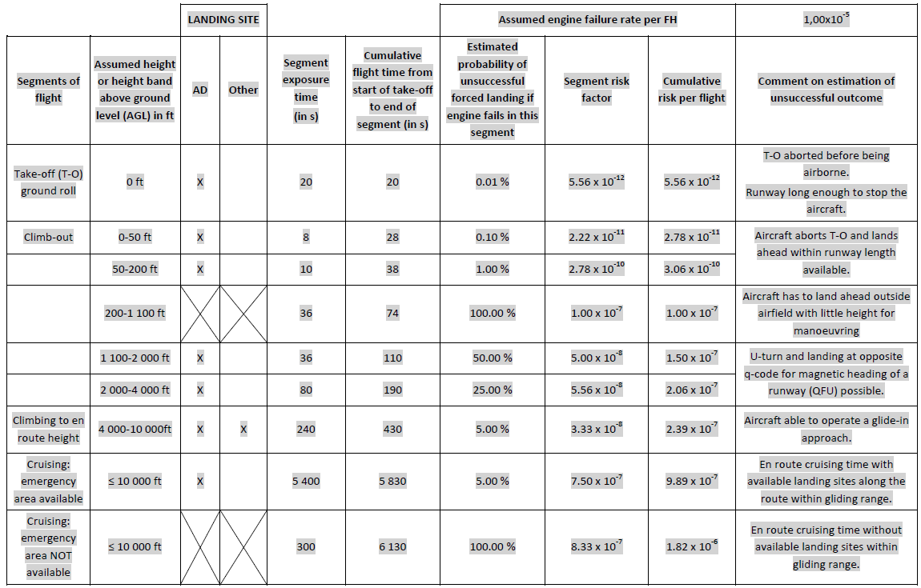
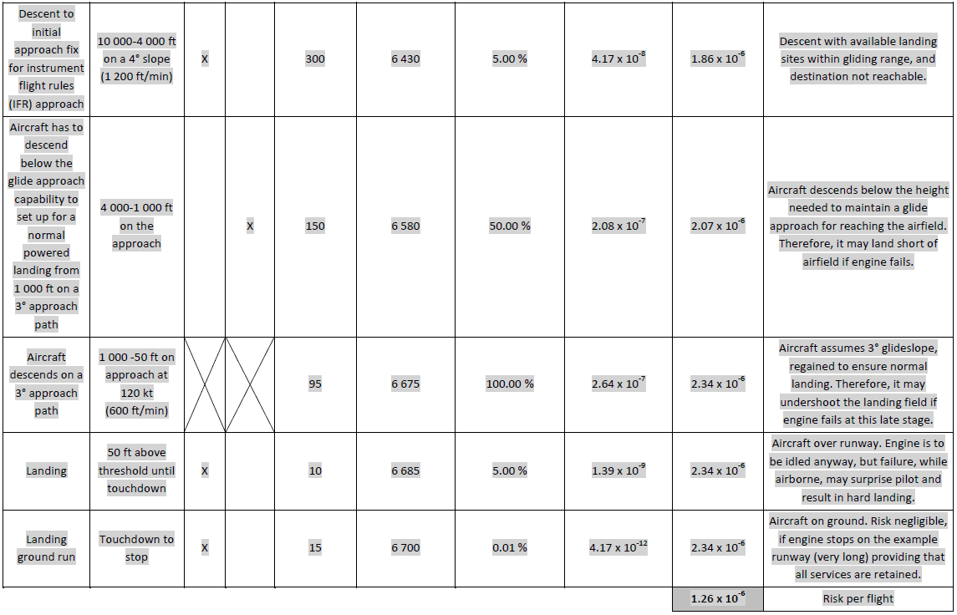
The following likelihood scale may be used to determine the estimated probability of an unsuccessful forced landing:

Probability in % | Description
0 | Impossible
0-1 | Negligible likelihood/remote possibility
1-10 | Possible but not likely
10-35 | Moderately likely
35-65 | Possible
65-90 | Likely
90-99 | Almost certain
99-100 | Certain

AMC1 SPA.SET-IMC.105(d)(4) SET-IMC operations approval
CONTINGENCY PROCEDURES

When a risk period is used during the take-off or landing phase, the contingency procedures should include appropriate information for the crew on the path to be followed after an engine failure in order to minimise to the greatest extent possible the risk to people on the ground.

SPA.SET-IMC.110 Equipment requirements for SET-IMC operations

Aeroplanes used for SET-IMC operations shall be equipped with all the following equipment:

(a) two separate electrical generating systems, each one capable of supplying adequate power to all essential flight instruments, navigation systems and aeroplane systems required for continued flight to the destination or alternate aerodrome;

(b) two attitude indicators, powered from independent sources;

(c) for passenger operations, a shoulder harness or a safety belt with a diagonal shoulder strap for each passenger seat;

(d) airborne weather-detecting equipment;

(e) in a pressurised aeroplane, sufficient supplemental oxygen for all occupants to allow descent, following engine failure at the maximum certificated cruising altitude, at the best range gliding speed and in the best gliding configuration, assuming the maximum cabin leak rate, until sustained cabin altitudes below 13 000 ft are reached;

(f) an area navigation system capable of being programmed with the positions of landing sites and providing lateral guidance to the flight crew to reach those sites;

(g) a radio altimeter;

(h) a landing light, capable of illuminating the touchdown point on the power-off glide path from 200 ft away;

(h) a landing light, capable of illuminating the touchdown point on the power-off glide path from 200 ft away;

(i) an emergency electrical supply system of sufficient capacity and endurance capable of providing power, following the failure of all generated power, to additional loads necessary for all of the following:

- the essential flight and area navigation instruments during descent from maximum operating altitude after engine failure;

- the means to provide for one attempt to restart the engine;

- if appropriate, the extension of landing gear and flaps;

- the use of the radio altimeter throughout the landing approach;

- the landing light;

- one pitot heater;

- if installed, the electrical means to give sufficient protection against impairment of the pilot's vision for landing;

(j) an ignition system that activates automatically, or is capable of being operated manually, for take-off, landing, and during flight, in visible moisture;

(k) a means of continuously monitoring the power train lubrication system to detect the presence of debris associated with the imminent failure of a drivetrain component, including a flight crew compartment caution indication;

(l) an emergency engine power control device that permits continuing operation of the engine at a sufficient power range to safely complete the flight in the event of any reasonably probable failure of the fuel control unit.

AMC1 SPA.SET-IMC.110(b) Equipment requirements for SET-IMC operations
ATTITUDE INDICATORS

A backup or standby attitude indicator built in the glass cockpit installations is an acceptable means of compliance for the second attitude indicator.

AMC1 SPA.SET-IMC.110(d) Equipment requirements for SET-IMC operations
AIRBORNE WEATHER-DETECTING EQUIPMENT
The airborne weather-detecting equipment should be an airborne weather radar, as defined in the applicable Certification Specification — European Technical Standard Order (CS-ETSO) issued by the Agency, or equivalent.

AMC1 SPA.SET-IMC.110(f) Equipment requirements for SET-IMC operations
AREA NAVIGATION SYSTEM

The area navigation system should be based on a global navigation satellite system (GNSS) stand-alone receiver or multi-sensor system, including at least one GNSS sensor, to enable at least required navigation performance approach (RNP APCH) operations without vertical guidance.

GM1 SPA.SET-IMC.110(f) Equipment requirements for SET-IMC operations
AREA NAVIGATION SYSTEM

Acceptable standards for the area navigation system are ETSO-145/146c, ETSO-C129a, ETSO-C196a or ETSO-C115 issued by the Agency, or equivalent.

GM1 SPA.SET-IMC.110(h) Equipment requirements for SET-IMC operations
LANDING LIGHTS

In order to demonstrate the compliance of its aeroplane’s landing lights with the 200-ft illumination capability requirement, and in the absence of relevant data available in the aircraft flight manual (AFM), the operator should liaise with the type certificate (TC) holder or supplemental type certificate (STC) holder, as applicable, to obtain a statement of compliance.

GM1 SPA.SET-IMC.110(i)(7) Equipment requirements for SET-IMC operations
ELEMENTS AFFECTING PILOT’S VISION FOR LANDING

Examples of elements affecting pilot’s vision for landing are rain, ice and window fogging.

AMC1 SPA.SET-IMC.110(l) Equipment requirements for SET-IMC operations
EMERGENCY ENGINE POWER CONTROL DEVICE

The means that allows continuing operation of the engine within a sufficient power range for the flight to be safely completed in the event of any reasonably probable failure/malfunction of the fuel control unit should enable the fuel flow modulation.

-END-

