 | Helicopter Offshore Operations (HOFO) Ver. 2021-02-26
Operatör:
Tillståndsnummer: |  | Ifylld EASA Form 2:
 |  | ☐
 |  |  | Bilaga nr:
Relevant elements defined in the mandatory part of the Operational Suitiability Data (OSD) established in accordance with Regulation (EU) No 748/2012 are taken into account

Transportstyrelsen
Ärendenummer: |  | Handläggare:
Berörda sektioner/samråd:

Information
Denna checklista är avsedd som stöd vid ansökan om helikopterverksamhet till havs (HOFO).
Checklistan kan användas av en operatör,
- som innehar ett giltigt, eller ansöker om drifttillstånd (AOC),
- som har deklarerat sin specialiserade verksamhet (SPO), eller
- som har deklarerat sin icke-kommersiella verksamhet (NCC).

Definition av verksamhet till havs (offshore operations): helikopterverksamhet där en betydande del av en flygning sker över havsområden till eller från en plats till havs.

Ange var i det operativa manualverket (eller i annat styrande dokument) momentet återfinns och detta så detaljerat som möjligt för att underlätta och påskynda granskning och handläggning.
Om en punkt inte är relevant, markera rutan med N/A samt en förklaring varför den inte är relevant.

Där grönmarkerade rutor förekommer ska relevanta bilagor sändas in.
Bilagans nummer ska anges i checklistan

SPA.GEN.105
(a) The operator applying for the initial issue of a specific approval shall provide to the competent authority the documentation required in the applicable Subpart, together with the following information:
 |  | TS notes:
(1) the name, address and mailing address of the applicant; | Ref EASA Form 2
 | Bilaga nr: | TS notes:
(2) a description of the intended operation.
(b) The operator shall provide the following evidence to the competent authority:
 |  | TS notes:
(1) compliance with the requirements of the applicable Subpart; | This compliance checklist
 |  | TS notes:
(2) that the relevant elements defined in the mandatory part of the operational suitability data established in accordance with Regulation (EU) No 748/2012 are taken into account. | Ref. header of this CCL
 | Ref in OM | TS notes:
(c) The operator shall retain records relating to (a) and (b) at least for the duration of the operation requiring a specific approval, or, if applicable, in accordance with Annex III (Part-ORO).

SPA.HOFO.100 Helicopter offshore operations (HOFO)
The requirements of this Subpart apply to (mark the applicable):
 |  | TS notes:
(a) a commercial air transport operator holding a valid AOC in accordance with Part-ORO; | ☐
 |  | TS notes:
(b) a specialised operations operator having declared its activity in accordance with Part-ORO; or | ☐
 |  | TS notes:
(c) a non-commercial operator having declared its activity in accordance with Part-ORO. | ☐

SPA.HOFO.105 Approval for helicopter offshore operations
(a) Prior to engaging in operations under this Subpart, a specific approval by the competent authority shall have been issued to the operator.
(b) To obtain such approval, the operator shall submit an application to the competent authority as specified in SPA.GEN.105, and shall demonstrate compliance with the requirements of this Subpart.
 | Ref in OM: | TS notes:
(c) The operator shall, prior to performing operations from a Member State other than the Member State that issued the approval under (a), inform the competent authorities in both Member States of the intended operation.

SPA.HOFO.110 Operating procedures
(a) The operator shall, as part of its safety management process, mitigate and minimise risks and hazards specific to helicopter offshore operations. The operator shall specify in the operations manual the:
 | Ref in OM: | TS notes:
(1) selection, composition and training of crews;
 | Ref in OM: | TS notes:
(2) duties and responsibilities of crew members and other involved personnel;
 | Ref in OM | TS notes:
(3) required equipment and dispatch criteria; and
 | Ref in OM | TS notes:
(4) operating procedures and minima, such that normal and likely abnormal operations are described and adequately mitigated.
(b) The operator shall ensure that:
 | Ref in OM | TS notes:
(1) an operational flight plan is prepared prior to each flight;
 | Ref in OM | TS notes:
(2) the passenger safety briefing also includes any specific information on offshore related items and is provided prior to boarding the helicopter;
 | Ref in OM | TS notes:
(3) each member of the flight crew wears an approved survival suit:
(i) when the weather report or forecasts available to the pilot-in-command/commander indicate that the sea temperature will be less than plus 10°C during the flight; or
(ii) when the estimated rescue time exceeds the calculated survival time; or
(iii) when the flight is planned to be conducted at night in a hostile environment;
 | Ref in OM | TS notes:
(4) where established, the offshore route structure provided by the appropriate ATS is followed;
 | Ref in OM | TS notes:
(5) pilots make optimum use of the automatic flight control systems (AFCS) throughout the flight;
 | Ref in OM | TS notes:
(6) specific offshore approach profiles are established, including stable approach parameters and the corrective action to be taken if an approach becomes unstable;

 | Ref in OM | TS notes:
(7) for multi-pilot operations, procedures are in place for a member of the flight crew to monitor the flight instruments during an offshore flight, especially during approach or departure, to ensure that a safe flight path is maintained;
 | Ref in OM | TS notes:
(8) the flight crew takes immediate and appropriate action when a height alert is activated;
 | Ref in OM | TS notes:
(9) procedures are in place to require the emergency flotation systems to be armed, when safe to do so, for all overwater arrivals and departures; and
 | Ref in OM | TS notes:
(10) operations are conducted in accordance with any restriction on the routes or the areas of operation specified by the competent authority or the appropriate authority responsible for the airspace.

AMC1 SPA.HOFO.110(a) Operating procedures

RISK ASSESSMENT
The operator’s risk assessment should include, but not be limited to, the following hazards:
 | Ref in OM: | TS notes:
(a) collision with offshore installations, vessels and floating structures;
(b) collision with wind turbines;
(c) collision with skysails;
(d) collision during low-level instrument meteorological conditions (IMC) operations;
(e) collision with obstacles adjacent to helidecks;
(f) collision with surface/water;
(g) IMC or night offshore approaches;
(h) loss of control during operations to small or moving offshore locations;
(i) operations to unattended helidecks; and
(j) weather and/or sea conditions that could either cause an accident or exacerbate its consequences.

AMC1 SPA.HOFO.110(b)(1) Operating procedures

OPERATIONAL FLIGHT PLAN
 | Ref in OM: | TS notes:
The operational flight plan should contain at least the items listed in AMC1 CAT.OP.MPA.175(a) Flight preparation.

AMC1 SPA.HOFO.110(b)(2) Operating procedures

PASSENGER BRIEFING
The following aspects applicable to the helicopter used should be presented and demonstrated to the passengers by audio-visual electronic means (video, DVD or similar), or the passengers should be informed about them by a crew member prior to boarding the aircraft:
 | Ref in OM: | TS notes:
(a) the use of the life jackets and where they are stowed if not in use;
 | Ref in OM: | TS notes:
(b) the proper use of survival suits, including briefing on the need to have suits fully zipped with, if applicable, hoods and gloves on, during take-off and landing or when otherwise advised by the pilot-in-command/commander;
 | Ref in OM: | TS notes:
(c) the proper use of emergency breathing equipment;
 | Ref in OM: | TS notes:
(d) the location and operation of the emergency exits;
 | Ref in OM: | TS notes:
(e) life raft deployment and boarding;
 | Ref in OM: | TS notes:
(f) deployment of all survival equipment; and
 | Ref in OM: | TS notes:
(g) boarding and disembarkation instructions.
 | Ref in OM: | TS notes:
When operating in a non-hostile environment, the operator may omit items related to equipment that is not required.

AMC1.1 SPA.HOFO.110(b)(2) Operating procedures

PASSENGER BRIEFING
This AMC is applicable to passengers who require more knowledge of the operational concept, such as sea pilots and support personnel for offshore wind turbines.
The operator may replace the passenger briefing as set out in AMC1 SPA.HOFO.110(b)(2) with a passenger training and checking programme provided that:
 | Ref in OM: | TS notes:
— the operator ensures that the passenger is appropriately trained and qualified on the helicopter types on which they are to be carried;
 | Ref in OM: | TS notes:
— the operator defines the training and checking programme for each helicopter type, covering all safety and emergency procedures for a given helicopter type, and including practical training;
 | Ref in OM: | TS notes:
— the passenger has received the above training within the last 12 calendar months; and
 | Ref in OM: | TS notes:
— the passenger has flown on the helicopter type within the last 90 days.

AMC1 SPA.HOFO.110(b)(5) Operating procedures

AUTOMATIC FLIGHT CONTROL SYSTEM (AFCS)
 | Ref in OM: | TS notes:
To ensure competence in manual handling of the helicopter, the operator should provide instructions to the flight crew in the operations manual (OM) under which circumstances the helicopter may be operated in lower modes of automation. Particular emphasis should be given to flight in instrument meteorological conditions (IMC) and instrument approaches.

GM1 SPA.HOFO.110(b)(9) Operating procedures
 | Ref in OM: | TS notes:
Emergency flotation systems (EFSs) cannot always be armed safely before the approach when a speed limitation needs to be complied with. In such case, the EFS should be armed as soon as safe to do so.

SPA.HOFO.115 Use of offshore locations
 | Ref in OM: | TS notes:
The operator shall only use offshore locations that are suitable in relation to size and mass of the type of helicopter and to the operations concerned.

AMC1 SPA.HOFO.115 Use of offshore locations
 | Ref in OM: | TS notes:
(a) The operations manual (OM) relating to the specific usage of offshore helicopter landing areas (Part C for CAT operators) should contain, or make reference to, a directory of helidecks (helideck directory (HD)) intended to be used by the operator. The directory should provide details of helideck limitations and a pictorial representation of each offshore location and its helicopter landing area, recording all necessary information of a permanent nature and using a standardised template. The HD entries should show, and be amended as necessary, the most recent status of each helideck concerning non-compliance with applicable national standards, limitations, warnings, cautions or other comments of operational importance. An example of a typical template is shown in Figure 1 of GM1 SPA.HOFO.115.

(see rulebook for full text: (b) – (g) plus GM1 and GM2)

SPA.HOFO.120 Selection of aerodromes and operating sites
(a) Onshore destination alternate aerodrome. Notwithstanding CAT.OP.MPA.181, NCC.OP.152, and SPO.OP.151, the pilot-in command/commander does not need to specify a destination alternate aerodrome in the operational flight plan when conducting flights from an offshore location to a land aerodrome if either:
 | Ref in OM: | TS notes:
(1) the destination aerodrome is defined as a coastal aerodrome, or
 | Ref in OM: | TS notes:
(2) the following criteria are met:
(i) the destination aerodrome has a published instrument approach;
(ii) the flight time is less than 3 hours; and
(iii) the published weather forecast valid from 1 hour prior, and 1 hour subsequent to the expected landing time specifies that:
(A) the cloud base is at least 700 feet above the minima associated with the instrument approach, or 1 000 feet above the destination aerodrome, whichever is the higher; and
(B) visibility is at least 2 500 meters.
 | Ref in OM: | TS notes:
(b) Offshore destination alternate helideck. The operator may select an offshore destination alternate helideck when all of the following criteria are met:
 | Ref in OM: | TS notes:
(1) An offshore destination alternate helideck shall be used only after the point of no return (PNR) and when an onshore destination alternative aerodrome is not geographically available. Prior to the PNR, an onshore destination alternate aerodrome shall be used.
 | Ref in OM: | TS notes:
(2) One engine inoperative (OEI) landing capability shall be attainable at the offshore destination alternate helideck.
 | Ref in OM: | TS notes:
(3) To the extent possible, helideck availability shall be guaranteed prior to PNR. The dimensions, configuration and obstacle clearance of individual helidecks or other sites shall be suitable for its use as an alternate helideck by each helicopter type intended to be used.
 | Ref in OM: | TS notes:
(4) Weather minima shall be established taking into account the accuracy and reliability of meteorological information.
 | Ref in OM: | TS notes:
(5) The MEL shall contain specific provisions for this type of operation.
 | Ref in OM: | TS notes:
(6) An offshore destination alternate helideck shall only be selected if the operator has established a procedure in the operations manual.

AMC1 SPA.HOFO.120 Selection of aerodromes and operating sites

COASTAL AERODROME
 | Ref in OM: | TS notes:
(a) Any alleviation from the requirement to select an alternate aerodrome for a flight to a coastal aerodrome under instrument flight rules (IFR) routing from offshore should be based on an individual safety risk assessment.
(b) The following should be taken into account:
 | Ref in OM: | TS notes:
(1) suitability of the weather based on the landing forecast for the destination;
 | Ref in OM: | TS notes:
(2) the fuel required to meet the IFR requirements of CAT.OP.MPA.150, NCC.OP.131 or SPO.OP.131 except for the alternate fuel;
 | Ref in OM: | TS notes:
(3) where the destination coastal aerodrome is not directly on the coast, it should be:
(i) within a distance that with the fuel specified in (b)(2), the helicopter is able, at any time after crossing the coastline, to return to the coast, descend safely, carry out an approach under visual flight rules (VFR) and land, with the VFR fuel reserves intact;
(ii) within 5 nm of the coastline; and
(iii) geographically sited so that the helicopter is able, within the rules of the air and within the landing forecast:
(A) to proceed inbound from the coast at 500-ft above ground level (AGL), and carry out an approach and landing under VFR; or
(B) to proceed inbound from the coast on an agreed route, and carry out an approach and landing under VFR;
 | Ref in OM: | TS notes:
(4) procedures for coastal aerodromes should be based on a landing forecast no worse than:
(i) by day, a cloud base of ≥ 400 ft above descent height (DH)/minimum descent height (MDH), and a visibility of 4 km, or, if descent over the sea is intended, a cloud base of 600 ft and a visibility of 4 km; or
(ii) by night, a cloud base of 1 000 ft and a visibility of 5 km;
 | Ref in OM: | TS notes:
(5) the descent to establish visual contact with the surface should take place over the sea or as part of the instrument approach;
 | Ref in OM: | TS notes:
(6) routings and procedures for coastal aerodromes nominated as such should be included in the operations manual (OM) (Part C for CAT operators);
 | Ref in OM: | TS notes:
(7) the minimum equipment list (MEL) should reflect the requirement for airborne radar and radio altimeter for this type of operation; and
 | Ref in OM: | TS notes:
(8) operational limitations for each coastal aerodrome should be specified in the OM.

AMC2 SPA.HOFO.120 Selection of aerodromes and operating sites

OFFSHORE DESTINATION ALTERNATE AERODROME
‘Aerodrome’ is referred to as ‘helideck’ in this AMC.
 | Ref in OM: | TS notes:
(a) Offshore destination alternate helideck landing environment
The landing environment at an offshore location proposed for use as an offshore destination alternate helideck should be pre-surveyed, together with the physical characteristics, such as the effect of wind direction and strength, as well as of turbulence established. This information, which should be available to the pilot-in-command/commander both at the planning stage and in-flight, should be published in an appropriate form in the operations manual (OM) (including the orientation of the helideck) so that the suitability of the alternate helideck can be assessed. This helideck should meet the criteria for size and obstacle clearance appropriate to the performance requirements of the type of helicopter concerned.
 | Ref in OM: | TS notes:
(b) Performance considerations
The use of an offshore destination alternate helideck should be restricted to helicopters that can achieve one engine inoperative (OEI) in ground effect (IGE) hover at an appropriate power rating above the helideck at the offshore location. Where the surface of the helideck or prevailing conditions (especially wind velocity) precludes an OEI IGE, OEI out-of-ground effect (OGE) hover performance at an appropriate power rating should be used to compute the landing mass. The landing mass should be calculated based on graphs provided in the operations manual (OM) (Part B for CAT operators). When this landing mass is computed, due account should be taken of helicopter configuration, environmental conditions and the operation of systems that have an adverse effect on performance. The planned landing mass of the helicopter, including crew, passengers, baggage, cargo plus 30-min final reserve fuel (FRF), should not exceed the OEI landing mass of the helicopter at the time of approach to the offshore destination alternate.
 | Ref in OM: | TS notes:
(c) Weather considerations
(1) Meteorological observations
When the use of an offshore destination alternate helideck is planned, the meteorological observations, both at the offshore destination and the alternate helideck, should be made by an observer acceptable to the authority responsible for the provision of meteorological services. Automatic meteorological-observation stations may be used.
 | Ref in OM: | TS notes:
(2) Weather minima
When the use of an offshore destination alternate helideck is planned, the operator should neither select an offshore location as destination nor as alternate helideck unless the weather forecasts for the two offshore locations indicate that during a period commencing 1 h before and ending 1 h after the expected time of arrival at the destination and the alternate helideck, the weather conditions will be at or above the planning minima shown in the following table:
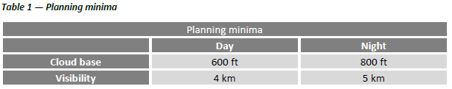
 | Ref in OM: | TS notes:
(3) Conditions of fog
To use an offshore destination alternate helideck, it should be ensured that fog is not forecast or present within 60 nm of the destination helideck and alternate helideck during the period commencing 1 h before and ending 1 h after the expected time of arrival at the offshore destination or alternate helideck.

(d) Actions at point of no return
Before passing the point of no return, which should not be more than 30 min from the destination, the following actions should have been completed:
 | Ref in OM: | TS notes:
(1) confirmation that navigation to the offshore destination and offshore destination alternate helideck can be assured;
 | Ref in OM: | TS notes:
(2) radio contact with the offshore destination and offshore destination alternate helideck (or master station) has been established;
 | Ref in OM: | TS notes:
(3) the landing forecast at the offshore destination and offshore destination alternate helideck have been obtained and confirmed to be at or above the required minima;
 | Ref in OM: | TS notes:
(4) the requirements for OEI landing (see (b) above) have been checked in the light of the latest reported weather conditions to ensure that they can be met; and
 | Ref in OM: | TS notes:
(5) to the extent possible, having regard to information on the current and forecast use of the offshore alternate helideck and on prevailing conditions, the availability of the helideck on the offshore location intended as destination alternate helideck should be guaranteed by the duty holder (the rig operator in the case of fixed installations, and the owner in the case of mobile ones) until the landing at the destination, or the offshore destination alternate helideck, has been achieved or until offshore shuttling has been completed.

SPA.HOFO.125 Airborne radar approaches (ARAs) to offshore locations – CAT operations
 | Ref in OM: | TS notes:
(a) A commercial air transport (CAT) operator shall establish operational procedures and ensure that ARAs are only flown if:
(1) the helicopter is equipped with a radar that is capable of providing information regarding the obstacle environment; and
 | Ref in OM: | TS notes:
(2) either:
(i) the minimum descent height (MDH) is determined from a radio altimeter; or
(ii) the minimum descent altitude (MDA) plus an adequate margin is applied.
 | Ref in OM: | TS notes:
(b) ARAs to rigs or vessels in transit shall be flown as multi-pilot operations.
 | Ref in OM: | TS notes:
(c) The decision range shall provide adequate obstacle clearance in the missed approach from any destination for which an ARA is planned.
 | Ref in OM: | TS notes:
(d) The approach shall only be continued beyond decision range or below the minimum descent altitude/height (MDA/H) when visual reference to the destination has been established.
 | Ref in OM: | TS notes:
(e) For single-pilot CAT operations, appropriate increments shall be added to the MDA/H and decision range.
 | Ref in OM: | TS notes:
(f) When an ARA is flown to a non-moving offshore location (i.e. fixed installation or moored vessel) and a reliable GPS position for the location is available in the navigation system, the GPS/area navigation system shall be used to enhance the safety of the ARA.

AMC1 SPA.HOFO.125 Airborne radar approach (ARA) to offshore locations
Note: alternative approach procedures using original equipment manufacturer (OEM)-certified approach systems are not covered by this AMC.

GENERAL
 | Ref in OM: | TS notes:
(a) Before commencing the final approach, the pilot-in-command/commander should ensure that a clear path exists on the radar screen for the final and missed approach segments. If lateral clearance from any obstacle will be less than 1 nm, the pilot-in-command/commander should:
(1) approach to a nearby target structure and thereafter proceed visually to the destination structure; or
(2) make the approach from another direction leading to a circling manoeuvre.
 | Ref in OM: | TS notes:
(b) The cloud ceiling should be sufficiently clear above the helideck to permit a safe landing.
 | Ref in OM: | TS notes:
(c) Minimum descent height (MDH) should not be less than 50 ft above the elevation of the helideck:
(1) the MDH for an airborne radar approach should not be lower than:
(i) 200 ft by day; or
(ii) 300 ft by night; and
(2) the MDH for an approach leading to a circling manoeuvre should not be lower than:
(i) 300 ft by day; or
(ii) 500 ft by night.
 | Ref in OM: | TS notes:
(d) Minimum descent altitude (MDA) may only be used if the radio altimeter is unserviceable. The MDA should be a minimum of the MDH + 200 ft, and be based on a calibrated barometer at the destination or on the lowest forecast barometric pressure adjusted to sea level (QNH) for the region.
 | Ref in OM: | TS notes:
(e) The decision range should not be less than 0.75 nm.
 | Ref in OM: | TS notes:
(f) The MDA/MDH for a single-pilot ARA should be 100 ft higher than that calculated in accordance with (c) and (d) above. The decision range should not be less than 1 nm.
 | Ref in OM: | TS notes:
(g) For approaches to non-moving offshore locations, the maximum range discrepancy between the global navigation satellite system (GNSS) and the weather radar display should not be greater than 0.3 nm at any point between the final approach fix (FAF) at 4 nm from the offshore location and the offset initiation point (OIP) at 1.5 nm from the offshore location.
 | Ref in OM: | TS notes:
(h) For approaches to non-moving offshore locations, the maximum bearing discrepancy between the GNSS and the weather radar display should not be greater than 10° at the FAF at 4 nm from the offshore location.

GM1 SPA.HOFO.125 Airborne radar approach (ARA) to offshore locations

GENERAL
 | Ref in OM: | TS notes:
(a) General
(1) The helicopter ARA procedure may have as many as five separate segments: the arrival, initial, intermediate, final approach, and missed approach segment. In addition, the specifications of the circling manoeuvre to a landing under visual conditions should be considered. The individual approach segments can begin and end at designated fixes. However, the segments of an ARA may often begin at specified points where no fixes are available.

 | Ref in OM: | TS notes:
(2) The fixes, or points, are named to coincide with the beginning of the associated segment. For example, the intermediate segment begins at the intermediate fix (IF) and ends at the final approach fix (FAF). Where no fix is available or appropriate, the segments begin and end at specified points; for example, at the intermediate point (IP) and final approach point (FAP). The order in which the segments are discussed in this GM is the order in which the pilot would fly them in a complete procedure: that is, from the arrival through the initial and intermediate to the final approach and, if necessary, to the missed approach.
 | Ref in OM: | TS notes:
(3) Only those segments that are required by local conditions applying at the time of the approach need to be included in a procedure. In constructing the procedure, the final approach track, which should be orientated so as to be substantially into the wind, should be identified first as it is the least flexible and most critical of all the segments. When the origin and the orientation of the final approach have been determined, the other necessary segments should be integrated with it to produce an orderly manoeuvring pattern that does not generate an unacceptably high workload for the flight crew.
 | Ref in OM: | TS notes:
(4) Where an ARA is conducted to a non-moving offshore location (i.e. fixed installation or moored vessel), and a reliable global navigation satellite system (GNSS) position for the location is available, the GNSS/area navigation system should be used to enhance the safety of the ARA. This is achieved by using the GNSS/area navigation system to navigate the helicopter onto, and maintain, the final approach track, and by using the GNSS range and bearing information to cross-check the position of the offshore location on the weather radar display.
 | Ref in OM: | TS notes:
(5) Examples of ARA procedures, as well as vertical profile and missed approach procedures, are contained in Figures 1 and 2 below.

 | Ref in OM: | TS notes:
(b) Obstacle environment
(1) Each segment of the ARA is located in an overwater area that has a flat surface at sea level. However, due to the passage of large vessels which are not required to notify their presence, the exact obstacle environment cannot be determined. As the largest vessels and structures are known to reach elevations exceeding 500 ft above mean sea level (AMSL), the uncontrolled offshore obstacle environment applying to the arrival, initial and intermediate approach segments can reasonably be assumed to be capable of reaching to at least 500 ft AMSL. Nevertheless, in the case of the final approach and missed approach segments, specific areas are involved within which no radar returns are allowed. In these areas, the height of wave crests, and the possibility that small obstacles may be present that are not visible on radar, results in an uncontrolled surface environment that extends to an elevation of 50 ft AMSL.
 | Ref in OM: | TS notes:
(2) Information about movable obstacles should be requested from the arrival destination or adjacent installations.
 | Ref in OM: | TS notes:
(3) Under normal circumstances, the relationship between the approach procedure and the obstacle environment is governed by the concept that vertical separation is very easy to apply during the arrival, initial and intermediate segments, while horizontal separation, which is much more difficult to guarantee in an uncontrolled environment, is applied only in the final and missed approach segments.
 | Ref in OM: | TS notes:
(c) Arrival segment
The arrival segment commences at the last en-route navigation fix, where the aircraft leaves the helicopter route, and it ends either at the initial approach fix (IAF) or, if no course reversal or similar manoeuvre is required, it ends at the IF. Standard en-route obstacle clearance criteria should be applied to the arrival segment.

 | Ref in OM: | TS notes:
(d) Initial approach segment
The initial approach segment is only required if the intermediate approach track cannot be joined directly. Most approaches will be flown direct to a point close to the IF, and then on to the final approach track, using GNSS/area navigation guidance. The segment commences at the IAF, and on completion of the manoeuvre, it ends at the IP. The minimum obstacle clearance (MOC) assigned to the initial approach segment is 1 000 ft.
 | Ref in OM: | TS notes:
(e) Intermediate approach segment
The intermediate approach segment commences at the IP, or in the case of straight-in approaches, where there is no initial approach segment, it commences at the IF. The segment ends at the FAP and should not be less than 2 nm in length. The purpose of the intermediate segment is to align the helicopter with the final approach track and prepare it for the final approach. During the intermediate segment, the helicopter should be lined up with the final approach track, the speed should be stabilised, the destination should be identified on the radar, and the final approach and missed approach areas should be identified and verified to be clear of radar returns. The MOC assigned to the intermediate segment is 500 ft.
 | Ref in OM: | TS notes:
(f) Final approach segment
(1) The final approach segment commences at the FAP and ends at the missed approach point (MAPt). The final approach area, which should be identified on radar, takes the form of a corridor between the FAP and the radar return of the destination. This corridor should not be less than 2 nm wide so that the projected track of the helicopter does not pass closer than 1 nm to the obstacles lying outside the area.

 | Ref in OM: | TS notes:
(2) On passing the FAP, the helicopter will descend below the intermediate approach altitude and follow a descent gradient which should not be steeper than 6.5 %. At this stage, vertical separation from the offshore obstacle environment will be lost. However, within the final approach area, the MDA/MDH will provide separation from the surface environment. Descent from 1 000 ft AMSL to 200 ft AMSL at a constant 6.5 % gradient will involve a horizontal distance of 2 nm. In order to follow the guideline that the procedure should not generate an unacceptably high workload for the flight crew, the required actions of levelling off at MDH, changing heading at the offset initiation point (OIP), and turning away at the MAPt, should not be planned to occur at the same time from the destination.
 | Ref in OM: | TS notes:
(3) During the final approach, compensation for drift should be applied, and the heading which, if maintained, would take the helicopter directly to the destination should be identified. It follows that at an OIP located at a range of 1.5 nm, a heading change of 10° is likely to result in a track offset of 15° at 1 nm, and the extended centre line of the new track can be expected to have a mean position approximately 300–400 m to one side of the destination structure. The safety margin built into the 0.75-nm decision range (DR) is dependent upon the rate of closure with the destination. Although the airspeed should be in the range of 60–90 KIAS during the final approach, the ground speed, after due allowance for wind velocity, should not be greater than 70 kt.
 | Ref in OM: | TS notes:
(g) Missed approach segment
(1) The missed approach segment commences at the MAPt and ends when the helicopter reaches the minimum en route altitude. The missed approach manoeuvre is a ‘turning missed approach’ which should be of not less than 30° and should not, normally, be greater than 45°. A turn away of more than 45° does not reduce the collision risk factor any further nor does it permit a closer DR. However, turns of more than 45° may increase the risk of pilot disorientation, and by inhibiting the rate of climb (especially in the case of an OEI missed approach procedure), may keep the helicopter at an extremely low level for longer than it is desirable.
 | Ref in OM: | TS notes:
(2) The missed approach area to be used should be identified and verified as a clear area on the radar screen during the intermediate approach segment. The base of the missed approach area is a sloping surface at 2.5 % gradient starting from MDH at the MAPt. The concept is that a helicopter executing a turning missed approach will be protected by the horizontal boundaries of the missed approach area until vertical separation of more than 130 ft is achieved between the base of the area and the offshore obstacle environment of 500 ft AMSL that prevails outside the area.
 | Ref in OM: | TS notes:
(3) A missed approach area, taking the form of a 45° sector orientated left or right of the final approach track, originating from a point 5 nm short of the destination, and terminating on an arc 3 nm beyond the destination, should normally satisfy the specifications of a 30° turning missed approach.
 | Ref in OM: | TS notes:
(h) Required visual reference
The visual reference required is that the destination should be in view in order to be able to carry out a safe landing.
 | Ref in OM: | TS notes:
(i) Radar equipment
During the ARA procedure, colour mapping radar equipment with a 120° sector scan and a 2.5-nm range scale selected may result in dynamic errors of the following order:
(1) bearing/tracking error of ± 4.5° with 95 % accuracy;
(2) mean ranging error of 250 m; or
(3) random ranging error of ± 250 m with 95 % accuracy.
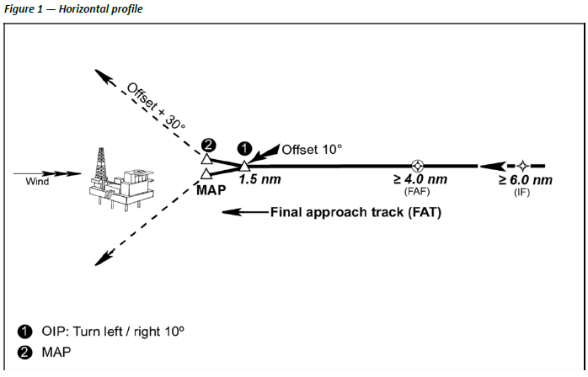
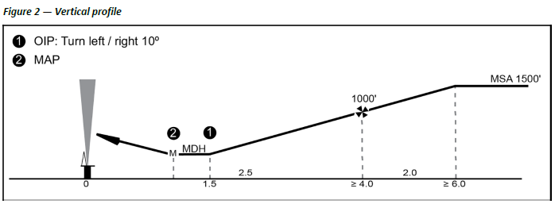

GM2 SPA.HOFO.125 Airborne radar approach (ARA) to offshore locations

GLOBAL NAVIGATION SATELLITE SYSTEM (GNSS)/AREA NAVIGATION SYSTEM
 | Ref in OM: | TS notes:
Where an ARA is conducted to a non-moving offshore location (i.e. fixed installation or moored vessel), and the GNSS/area navigation system is used to enhance the safety of the ARA, the following procedure or equivalent should be applied:
(a) selection from the area navigation system database or manual entry of the offshore location;
(b) manual entry of the final approach fix (FAF) or intermediate fix (IF), as a range of and bearing from the offshore location;
(c) operation of the GNSS equipment in terminal mode;
(d) comparison of weather radar and GNSS range and bearing data to cross-check the position of the offshore location;
(e) use of GNSS guidance to guide the aircraft onto the final approach track during the initial or intermediate approach segments;
(f) use of GNSS guidance from the FAF towards the offset initiation point (OIP) during the final approach segment to establish the helicopter on the correct approach track and, hence, heading;
(g) transition from GNSS guidance to navigation based on headings once the track is stabilised and before reaching OIP;
(h) use of GNSS range of and bearing to the offshore location during the intermediate and final approach segments to cross-check weather radar information (for correct ‘painting’ of the destination and, hence, of other obstacles);
(i) use of GNSS range of the offshore location to enhance confidence in the weather radar determination of arrival at the OIP and MAPt; and
(j) use of GNSS range of and bearing to the destination to monitor separation from the offshore location.

SPA.HOFO.130 Meteorological conditions
 | Ref in OM: | TS notes:
Notwithstanding CAT.OP.MPA.247, NCC.OP.180 and SPO.OP.170, when flying between offshore locations located in class G airspace where the overwater sector is less than 10 NM, VFR flights may be conducted when the limits are at, or better than, the following:
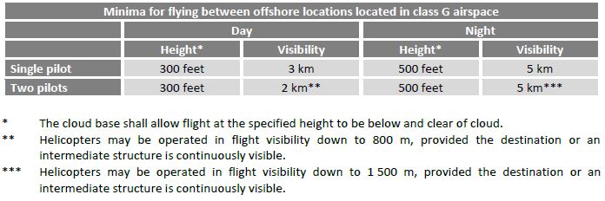

SPA.HOFO.135 Wind limitations for operations to offshore locations
 | Ref in OM: | TS notes:
Operation to an offshore location shall only be performed when the wind speed at the helideck is reported to be not more than 60 knots including gusts.

SPA.HOFO.140 Performance requirements at offshore locations
 | Ref in OM: | TS notes:
Helicopters taking off from and landing at offshore locations shall be operated in accordance with the performance requirements of the appropriate Annex according to their type of operation.

AMC1 SPA.HOFO.140 Performance requirements at offshore locations

FACTORS
 | Ref in OM: | TS notes:
To ensure that the necessary factors are taken into account, operators not conducting CAT operations should use take-off and landing procedures that are appropriate to the circumstances and have been developed in accordance with ORO.MLR.100 in order to minimise the risks of collision with obstacles at the individual offshore location under the prevailing conditions.

SPA.HOFO.145 Flight data monitoring (FDM) system
 | Ref in OM: | TS notes:
(a) When conducting CAT operations with a helicopter equipped with a flight data recorder, the operator shall establish and maintain a FDM system, as part of its integrated management system, by 1 January 2019.
 | Ref in OM: | TS notes:
(b) The FDM system shall be non-punitive and contain adequate safeguards to protect the source(s) of the data.

AMC1 SPA.HOFO.145 Flight data monitoring (FDM) system

FDM PROGRAMME
Refer to AMC1 ORO.AOC.130.
Note: Appendix 1 to AMC1 ORO.AOC.130 is not valid for helicopters.

GM1 SPA.HOFO.145 Flight data monitoring (FDM) system

DEFINITION OF AN FDM PROGRAMME
Refer to GM1 ORO.AOC.130, except for the examples that are specific to aeroplane operation.

GM2 SPA.HOFO.145 Flight data monitoring (FDM) system

FDM
Additional guidance material for the establishment of a FDM programme is found in:
(a) International Civil Aviation Organization (ICAO) Doc 10000 — Manual on Flight Data Analysis Programmes (FDAP); and
(b) United Kingdom Civil Aviation Authority (UK CAA) CAP 739 — Flight Data Monitoring.
The following table provides examples of FDM events that may be further developed using operator- and helicopter-specific limits. The table is considered illustrative and non-exhaustive.
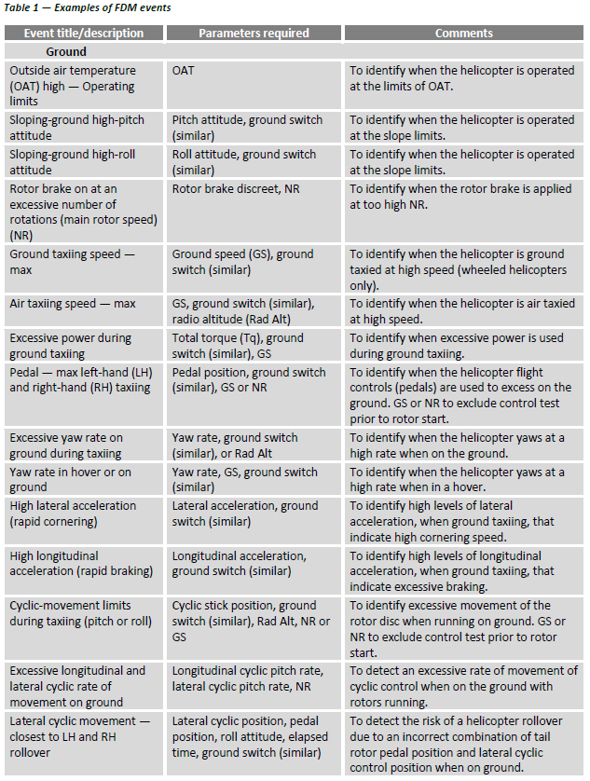
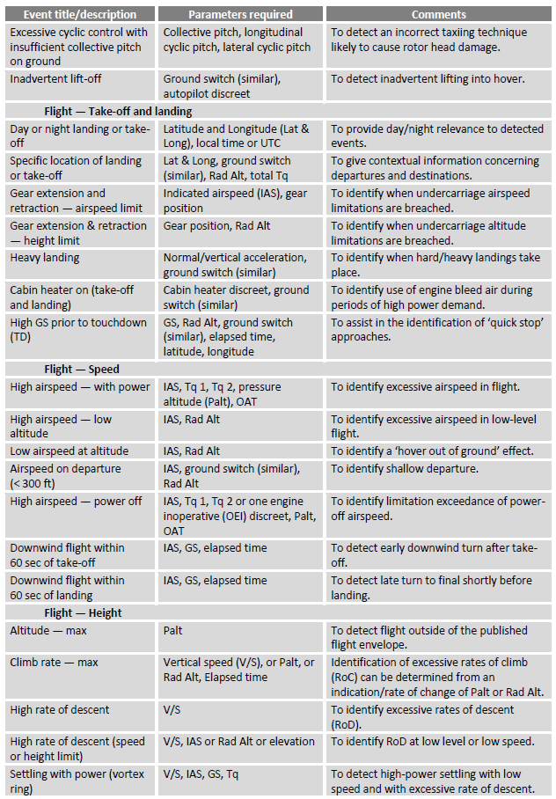
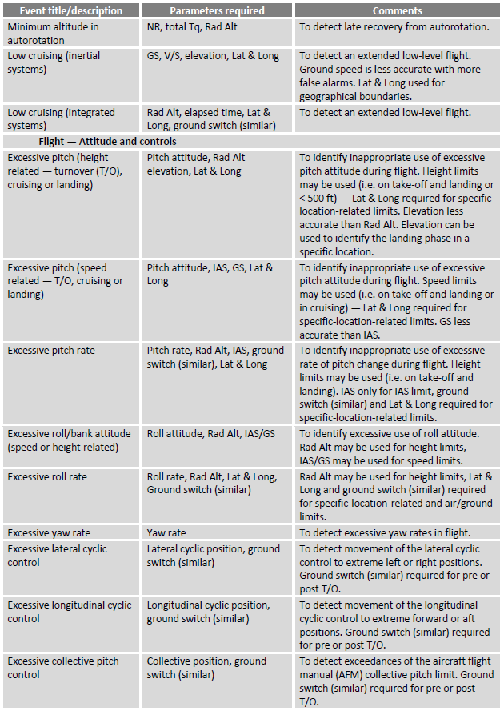
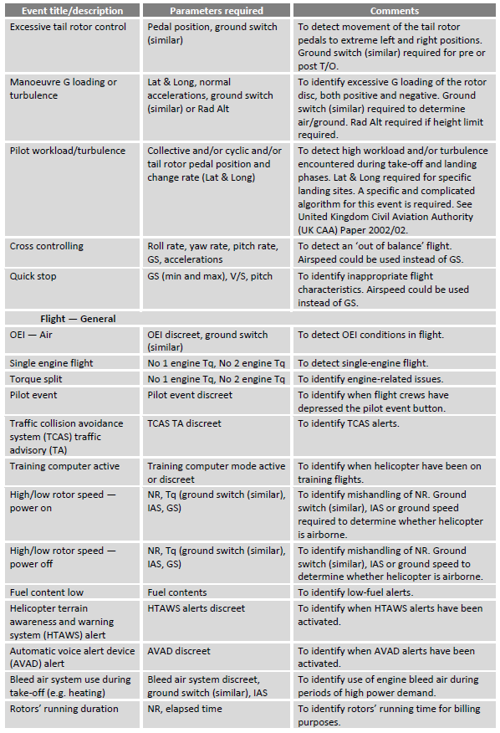
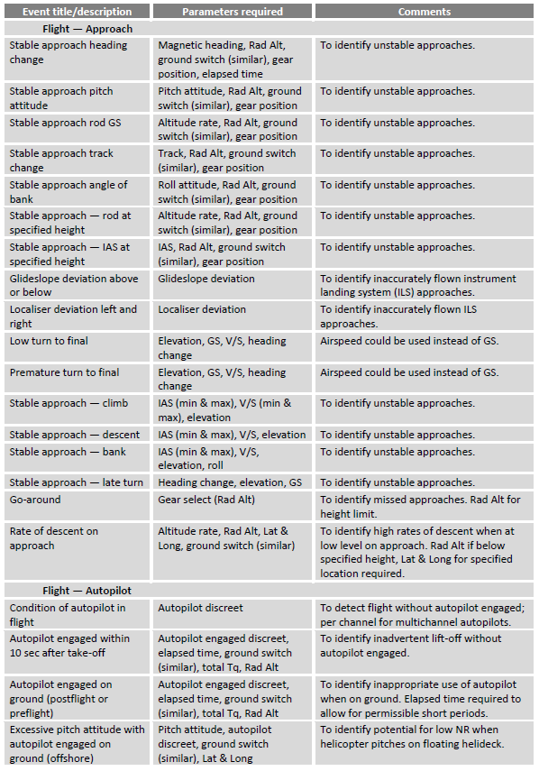
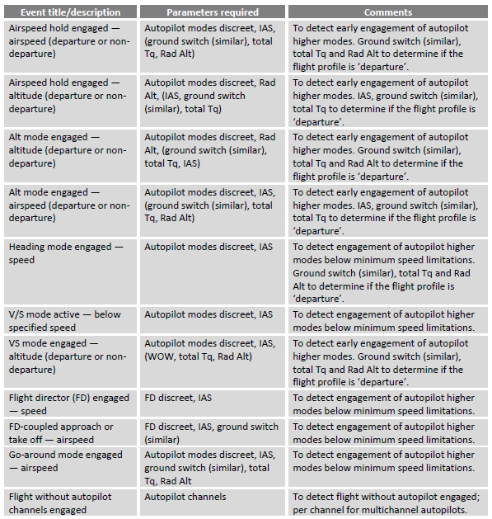

SPA.HOFO.150 Aircraft tracking system
 | Ref in OM: | TS notes:
An operator shall establish and maintain a monitored aircraft tracking system for offshore operations in a hostile environment from the time the helicopter departs until it arrives at its final destination.

AMC1 SPA.HOFO.150 Aircraft tracking system

GENERAL
 | Ref in OM: | TS notes:
Flights should be tracked and monitored from take-off to landing. This function may be achieved by the air traffic services (ATS) when the planned route and the planned diversion routes are fully included in airspace blocks where:
(a) ATS surveillance service is normally provided and supported by ATC surveillance systems locating the aircraft at time intervals with adequate duration; and
(b) the operator has given to competent air navigation services (ANS) providers the necessary contact information.
In all other cases, the operator should establish a detailed procedure describing how the aircraft tracking system is to be monitored, and what actions and when are to be taken if a deviation or anomaly has been detected.

GM1 SPA.HOFO.150 Aircraft tracking system

OPERATIONAL PROCEDURE
 | Ref in OM: | TS notes:
The procedure should take into account the following aspects:
(a) the outcome of the risk assessment made when the update frequency of the information was defined;
(b) the local environment of the intended operations; and
(c) the relationship with the operator’s emergency response plan.
Aircraft tracking data should be recorded on the ground and retained for at least 48 h. Following an accident or a serious incident subject to investigation, the data should be retained for at least 30 days, and the operator should be capable of providing a copy of this data without delay.

SPA.HOFO.155 Vibration health monitoring (VHM) system
 | Ref in OM: | TS notes:
(a) The following helicopters conducting CAT offshore operations in a hostile environment shall be fitted with a VHM system capable of monitoring the status of critical rotor and rotor drive systems by 1 January 2019:
(1) complex motor-powered helicopters first issued with an individual Certificate of Airworthiness (CofA) after 31 December 2016;
(2) all helicopters with a maximum operational passenger seating configuration (MOPSC) of more than 9 and first issued with an individual CofA before 1 January 2017;
(3) all helicopters first issued with an individual CofA after 31 December 2018.
 | Ref in OM: | TS notes:
(b) The operator shall have a system to:
(1) collect the data including system generated alerts;
(2) analyse and determine component serviceability; and
(3) respond to detected incipient failures.

AMC1 SPA.HOFO.155 Vibration health monitoring (VHM) system

GENERAL
 | Ref in OM: | TS notes:
Any VHM system should meet all of the following criteria:
(a) VHM system capability
The VHM system should measure vibration characteristics of rotating critical components during flight, using suitable vibration sensors, techniques, and recording equipment. The frequency and flight phases of data measurement should be established together with the type certificate holder (TCH) during the initial entry into service. In order to appropriately manage the generated data and focus upon significant issues, an alerting system should be established; this is normally automatic. Accordingly, alert generation processes should be developed to reliably advise maintenance personnel of the need to intervene and help determine what type of intervention is required.

 | Ref in OM: | TS notes:
(b) Approval of VHM installation
The VHM system, which typically comprises vibration sensors and associated wiring, data acquisition and processing hardware, the means of downloading data from the helicopter, the ground-based system and all associated instructions for operation of the system, should be certified in accordance with CS-29 or equivalent, established by the Agency.
Note: for applications that may also provide maintenance credit (see Federal Aviation Administration (FAA) Advisory Circular (AC) 29-2C Miscellaneous Guidance (MG) 15), the level of system integrity required may be higher.
 | Ref in OM: | TS notes:
(c) Operational procedures
The operator should establish procedures to address all necessary VHM subjects.
 | Ref in OM: | TS notes:
(d) Training
The operator should determine which staff will require VHM training, determine appropriate syllabi, and incorporate them into the operator’s initial and recurrent training programmes.

GM1 SPA.HOFO.155 Vibration health monitoring (VHM) system

GENERAL
Operators should utilise available international guidance material provided for the specification and design of VHM systems.
Further guidance can be found in:
(a) CS 29.1465 Vibration health monitoring and associated AMC;
(b) Federal Aviation Administration (FAA) Advisory Circular (AC) 29-2C Miscellaneous Guidance (MG) 15 — Airworthiness Approval of Rotorcraft Health Usage Monitoring Systems (HUMSs); and
(c) United Kingdom Civil Aviation Authority (UK CAA) CAP 753 — Helicopter Vibration Health Monitoring.

SPA.HOFO.160 Equipment requirements
(a) The operator shall comply with the following equipment requirements:
 | Ref in OM: | TS notes:
(1) Public Address (PA) system in helicopters used for CAT and non-commercial operations with complex motor-powered helicopters (NCC):
(i) Helicopters with a maximum operational passenger seat configuration (MOPSC) of more than 9 shall be equipped with a PA system.
 | Ref in OM: | TS notes:
(ii) Helicopters with an MOPSC of 9 or less need not be equipped with a PA system if the operator can demonstrate that the pilot’s voice is understandable at all passengers’ seats in flight.
 | Ref in OM: | TS notes:
(2) Radio altimeter
Helicopters shall be equipped with a radio altimeter that is capable of emitting an audio warning below a pre-set height and a visual warning at a height selectable by the pilot.
 | Ref in OM: | TS notes:
(b) Emergency exits
All emergency exits, including crew emergency exits, and any door, window or other opening that is suitable for emergency egress, and the means for opening them shall be clearly marked for the guidance of occupants using them in daylight or in the dark. Such markings shall be designed to remain visible if the helicopter is capsized or the cabin is submerged.
 | Ref in OM: | TS notes:
(c) Helicopter terrain awareness warning system (HTAWS)
Helicopters used in CAT operations with a maximum certificated take-off mass of more than 3 175 kg or a MOPSC of more than 9 and first issued with an individual CofA after 31 December 2018 shall be equipped with an HTAWS that meets the requirements for class A equipment as specified in an acceptable standard.

GM1 SPA.HOFO.160(a)(1) Additional equipment requirements

PUBLIC ADDRESS (PA) SYSTEM
 | Ref in OM: | TS notes:
When demonstrating the performance of the PA system or that the pilot’s voice is understandable at all passengers’ seats during flight, the operator should ensure compatibility with the passengers’ use of ear defenders/ear plugs (hearing protection). The operator should only provide hearing protection that is compatible with the intelligibility of the PA system or pilot’s voice, as appropriate.

GM1 SPA.HOFO.160(a)(2) Additional equipment requirements

RADIO ALTIMETER
For additional information, please refer to AMC1 CAT.IDE.H.145 Radio altimeters and AMC2 CAT.IDE.H.145 Radio altimeters, as well as to GM1 CAT.IDE.H.145 Radio altimeters.

SPA.HOFO.165 Additional procedures and equipment for operations in a hostile environment
 | Ref in OM: | TS notes:
(a) Life jackets
Approved life jackets shall be worn at all times by all persons on board unless integrated survival suits that meet the combined requirement of the survival suit and life jacket are worn.
 | Ref in OM: | TS notes:
(b) Survival suits
All passengers on board shall wear an approved survival suit:
(1) when the weather report or forecasts available to the commander/pilot-in-command indicate that the sea temperature will be less than plus 10 °C during the flight; or
(2) when the estimated rescue time exceeds the calculated survival time; or
(3) when the flight is planned to be conducted at night.
 | Ref in OM: | TS notes:
(c) Emergency breathing system
All persons on board shall carry and be instructed in the use of emergency breathing systems.
 | Ref in OM: | TS notes:
(d) Life rafts
(1) All life rafts carried shall be installed so as to be usable in the sea conditions in which the helicopter’s ditching, flotation, and trim characteristics were evaluated for certification.
(2) All life rafts carried shall be installed so as to facilitate their ready use in an emergency.
(3) The number of life rafts installed:
(i) in the case of a helicopter carrying less than 12 persons, at least one life raft with a rated capacity of not less than the maximum number of persons on board; or
(ii) in the case of a helicopter carrying more than 11 persons, at least two life rafts, sufficient together to accommodate all persons capable of being carried on board and, if one is lost, the remaining life raft(s) having the overload capacity sufficient to accommodate all persons on the helicopter.
(4) Each life raft shall contain at least one survival emergency locator transmitter (ELT(S)); and
(5) Each life raft shall contain life-saving equipment, including means of sustaining life, as appropriate to the flight to be undertaken.

 | Ref in OM: | TS notes:
(e) Emergency cabin lighting
The helicopter shall be equipped with an emergency lighting system with an independent power supply to provide a source of general cabin illumination to facilitate the evacuation of the helicopter.
 | Ref in OM: | TS notes:
(f) Automatically deployable emergency locator transmitter (ELT(AD))
The helicopter shall be equipped with an ELT(AD) that is capable of transmitting simultaneously on 121,5 MHz and 406 MHz.
 | Ref in OM: | TS notes:
(g) Securing of non-jettisonable doors
Non-jettisonable doors that are designated as ditching emergency exits shall have a means of securing them in the open position so that they do not interfere with the occupants’ egress in all sea conditions up to the maximum sea conditions required to be evaluated for ditching and flotation.
 | Ref in OM: | TS notes:
(h) Emergency exits and escape hatches
All emergency exits, including crew emergency exits, and any door, window or other opening suitable to be used for the purpose of underwater escape shall be equipped so as to be operable in an emergency.
 | Ref in OM: | TS notes:
(i) Notwithstanding (a), (b) and (c) above the operator may, based on a risk assessment, allow passengers, medically incapacitated at an offshore location, to partly wear or not wear life jackets, survival suits or emergency breathing systems on return flights or flights between offshore locations.

AMC1 SPA.HOFO.165(c) Additional procedures and equipment for operations in hostile environment

EMERGENCY BREATHING SYSTEM (EBS)
 | Ref in OM: | TS notes:
The EBS of SPA.HOFO.165(c) should be an EBS system capable of rapid underwater deployment.

AMC1 SPA.HOFO.165(d) Additional procedures and equipment for operations in hostile environment

INSTALLATION OF THE LIFE RAFT
 | Ref in OM: | TS notes:
(a) Projections on the exterior surface of the helicopter that are located in a zone delineated by boundaries that are 1.22 m (4 ft) above and 0.61 m (2 ft) below the established static waterline could cause damage to a deployed life raft. Examples of projections that need to be considered are aerials, overboard vents, unprotected split-pin tails, guttering, and any projection sharper than a three-dimensional right-angled corner.
 | Ref in OM: | TS notes:
(b) While the boundaries specified in (a) above are intended as a guide, the total area that should be considered should also take into account the likely behaviour of the life raft after deployment in all sea states up to the maximum in which the helicopter is capable of remaining upright.
 | Ref in OM: | TS notes:
(c) Wherever a modification or alteration is made to a helicopter within the boundaries specified, the need to prevent the modification or alteration from causing damage to a deployed life raft should be taken into account in the design.
 | Ref in OM: | TS notes:
(d) Particular care should also be taken during routine maintenance to ensure that additional hazards are not introduced by, for example, leaving inspection panels with sharp corners proud of the surrounding fuselage surface, or by allowing door sills to deteriorate to a point where their sharp edges may become a hazard.

AMC1 SPA.HOFO.165(h) Additional procedures and equipment for operations in a hostile environment

EMERGENCY EXITS AND ESCAPE HATCHES
In order for all passengers to escape from the helicopter within an expected underwater survival time of 60 sec in the event of capsize, the following provisions should be made:
 | Ref in OM: | TS notes:
(a) there should be an easily accessible emergency exit or suitable opening for each passenger;

 | Ref in OM: | TS notes:
(b) an opening in the passenger compartment should be considered suitable as an underwater escape facility if the following criteria are met:
(1) the means of opening should be rapid and obvious;
(2) passenger safety briefing material should include instructions on the use of such escape facilities;
(3) for the egress of passengers with shoulder width of 559 mm (22 in.) or smaller, a rectangular opening should be no smaller than 356 mm (14 in.) wide, with a diagonal between corner radii no smaller than 559 mm (22 in.), when operated in accordance with the instructions;
(4) non-rectangular or partially obstructed openings (e.g. by a seat back) should be capable of admitting an ellipse of 559 mm x 356 mm (22 in. x 14 in.); and
(5) for the egress of passengers with shoulder width greater than 559 mm (22 in.), openings should be no smaller than 480 mm x 660 mm (19 in. x 26 in.) or be capable of admitting an ellipse of 480 mm x 660 mm (19 in. x 26 in.);
 | Ref in OM: | TS notes:
(c) suitable openings and emergency exits should be used for the underwater escape of no more than two passengers, unless large enough to permit the simultaneous egress of two passengers side by side:
(1) if the exit size provides an unobstructed area that encompasses two ellipses of size 480 mm x 660 m (19 in. x 26 in.) side by side, then it may be used for four passengers; and
(2) if the exit size provides an unobstructed area that encompasses two ellipses of size 356 mm x 559 mm (14 in. x 22 in.) side by side, then it may be used for four passengers with shoulder width no greater than 559 mm (22 in.) each; and
 | Ref in OM: | TS notes:
(d) passengers with shoulder width greater than 559 mm (22 in.) should be identified and allocated to seats with easy access to an emergency exit or opening that is suitable for them.

GM1 SPA.HOFO.165(h) Additional procedures and equipment for operations in a hostile environment

SEAT ALLOCATION
 | Ref in OM: | TS notes:
The identification and seating of the larger passengers might be achieved through the use of patterned and/or colour-coded armbands and matching seat headrests.

AMC1 SPA.HOFO.165(i) Additional procedures and equipment for operations in a hostile environment

MEDICALLY INCAPACITATED PASSENGER
 | Ref in OM: | TS notes:
(a) A ‘Medically incapacitated passenger’ means a person who is unable to wear the required survival equipment, including life jackets, survival suits and emergency breathing systems (EBSs), as determined by a medical professional. The medical professional’s determination should be made available to the pilot-in-command/commander prior to arrival at the offshore installation.
 | Ref in OM: | TS notes:
(b) The operator should establish procedures for the cases where the pilot-in-command/commander may accept a medically incapacitated passenger not wearing or partially wearing survival equipment. To ensure proportionate mitigation of the risks associated with an evacuation, the procedures should be based on, but not be limited to, the severity of the incapacitation, sea and air temperature, sea state, and number of passengers on board.
In addition, the operator should establish the following procedures:
(1) under which circumstances one or more dedicated persons are required to assist a medically incapacitated passenger during a possible emergency evacuation, and the skills and qualifications required;
(2) seat allocation for the medically incapacitated passenger and possible assistants in the helicopter types used to ensure optimum use of the emergency exits; and
(3) evacuation procedures related to whether or not the dedicated persons as described in (1) above are present.

SPA.HOFO.170 Crew requirements
(a) The operator shall establish:
 | Ref in OM: | TS notes:
(1) criteria for the selection of flight crew members, taking into account the flight crew members’ previous experience;
 | Ref in OM: | TS notes:
(2) a minimum experience level for a commander/pilot-in-command intending to conduct offshore operations; and
 | Ref in OM: | TS notes:
(3) a flight crew training and checking programme that each flight crew member shall complete successfully. Such programme shall be adapted to the offshore environment and include normal, abnormal and emergency procedures, crew resource management, water entry and sea survival training.
(b) Recency requirements
A pilot shall only operate a helicopter carrying passengers:
 | Ref in OM: | TS notes:
(1) at an offshore location, as commander or pilot-in-command, or co-pilot, when he or she has carried out in the preceding 90 days at least 3 take-offs, departures, approaches and landings at an offshore location in a helicopter of the same type or a full flight simulator (FFS) representing that type; or
 | Ref in OM: | TS notes:
(2) by night at an offshore location, as commander or pilot-in-command, or co-pilot, when he/she has carried out in the preceding 90 days at least 3 take-offs, departures, approaches and landings at night at an offshore location in a helicopter of the same type or an FFS representing that type.
The 3 take-offs and landings shall be performed in either multi-pilot or single-pilot operations, depending on the operation to be performed.
(c) Specific requirements for CAT:
 | Ref in OM: | TS notes:
(1) The 90-day period presented in points (b)(1) and (2) above may be extended to 120 days as long as the pilot undertakes line flying under the supervision of a type rating instructor or examiner.
 | Ref in OM: | TS notes:
(2) If the pilot does not comply with the requirements in (1), he/she shall complete a training flight in the helicopter or an FFS of the helicopter type to be used, which shall include at least the requirements described in (b)(1) and (2) before he or she can exercise his or her privileges.

AMC1 SPA.HOFO.170(a) Crew requirements

FLIGHT CREW TRAINING AND CHECKING
 | Ref in OM: | TS notes:
(a) Flight crew training programmes should:
(1) improve knowledge of the offshore operations environment with particular consideration of visual illusions during approach, introduced by lighting, motion and weather factors;
(2) improve crew cooperation specifically for offshore operations;
(3) provide flight crew members with the necessary skills to appropriately manage the risks associated with normal, abnormal and emergency procedures during flights by day and night;
(4) if night operations are conducted, give particular consideration to approach, go-around, landing, and take-off phases;
(5) include instructions on the optimum use of the helicopter’s automatic flight control system (AFCS);
(6) for multi-pilot operation, emphasise the importance of multi-crew procedures, as well as the role of the pilot monitoring during all phases of the flight; and
(7) include standard operating procedures.
 | Ref in OM: | TS notes:
(b) Emergency and safety equipment training should focus on the equipment fitted/carried. Water entry and sea survival training, including operation of all associated safety equipment, should be an element of the recurrent training, as described in AMC1 ORO.FC.230(a)(2)(iii)(F).
 | Ref in OM: | TS notes:
(c) The training elements referred to above should be assessed during: operator proficiency checks, line checks, or, as applicable, emergency and safety equipment checks.
 | Ref in OM: | TS notes:
(d) Training and checking should make full use of full flight simulators (FFSs) for normal, abnormal, and emergency procedures related to all aspects of helicopter offshore operations (HOFO).

